***PRACTICAL 6***

***FUNCTIONS***

**1. Write a PL/SQL program of function to add two numbers.**

**Code:**

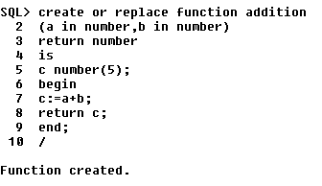

**Output:**

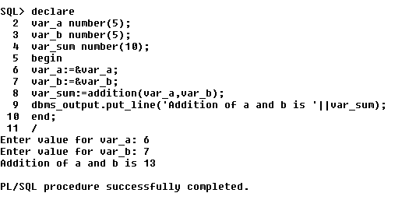

**2.fact**

**3.fibo 4 terms.**

**4. Consider schema book(id,name,quantity).Write a function to accept book name and display its quantity.**

**5. Consider schema employee(id, sal).Write a function to display average of employee salary.**

**6. Write a function to calculate S.I. Accept required values from user.**